Bench Booths provide a full height spray booth of 2250mm internally with a shelf at a good working height of 920mm from the floor for painting smaller workpieces. The shelf is the full internal width of the booth by 500mm deep. These units are fitted with a backward curved fan and are inverter driven for controllable airflow. The duct connection is on the top for vertical exhaust.
Dry Filter Bench Booths and Extraction Boxes typically extract air from the painting area through a single row of dry filter media and exhausts to atmosphere. There are different types of filter media. We primarily offer the Andreae and Binks type concertina folded paper filters.
- Manufactured from Galvanised Steel
- Natural Finish or Optional Powder Coated
- Modular Design
- Inverter Driven Centrifugal Fan Version
- For Wet Spray Processes

Extraction Boxes provide local air extraction to open rooms used for painting where a spray booth is not practical. These units are fitted with a backward curved fan and are inverter driven for controllable airflow. Available from 1.5M to 3M, they can be rowed up to cover larger areas. The duct connection is on the top for vertical exhaust.
All standard units are provided with extraction for a maximum of 6M straight and 2x90° bends.
 |  | 1.5M Bench Booth | 2M Bench Booth |  |  |  | 1.5M Extract Box | 2M Extract Box | 2.5M Extract Box | 3M Extract Box
BENCH BOOTHS – BC FAN |  | 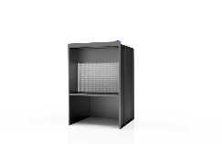 | 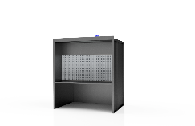 |  | EXTRACTION BOXES – BC FAN |  | 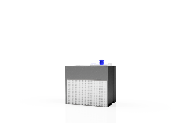 | 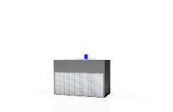 | 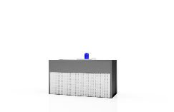 | 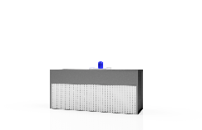
 | Model | SBB-1.5 | SBB-2 |  |  | Model | SEC-1.5 | SEC-2 | SEC-2.5 | SEC3
 | Front Opening | 1500w x 1330h | 2000w x 1330h |  |  | Filter Area | 1500w x 900h | 2000w x 900h | 2500w x 900h | 3000w x 900h
 | Width | 1600 | 2100 |  |  | Width | 1600 | 2100 | 2600 | 3100
 | Depth | 1500 | 1500 |  |  | Depth | 1000 | 1000 | 1000 | 1000
 | Height | 2370 | 2370 |  |  | Height | 1380 | 1380 | 1380 | 1380
 | Bench Height | 920 | 920 |  |  | Airflow @1 M /Sec | 1.35 M³/Sec | 1.8 M³/Sec | 2.25 M³/Sec | 2.7 M³/Sec
 | Bench Depth | 500 | 500 |  |  | Airflow @1 M /Sec | 4860 M³/Hr | 6480 M³/Hr | 8100 M³/Hr | 9720 M³/Hr
 | Airflow @0.7 M/Sec | 1.4 M/Sec | 1.86 M/Sec |  |  | Fan Qty | 1 | 1 | 1 | 1
 | Airflow @0.7 M/Sec | 5027 M³/Hr | 6703 M³/Hr |  |  | Power kW | 0.55 kW | 1.1 kW | 1.5 kW | 1.5 kW
 | Fan Qty | 1 | 1 |  |  | Duct Diameter | 450 | 500 | 560 | 630
 | Power kW | 0.55 kW | 1.1 kW
 | Duct Diameter | 450 | 500
 | Lighting | 1 LED 40W | 1 LED 40W

Centrifugal Fan Dry Filter Booths provide a full height spray booth of 2250mm internally. These units are fitted with a backward curved fan and are inverter driven for controllable airflow. The duct connection is on the top for vertical exhaust. Depending on the size of booth, there are 1 or 2 exhaust fans and ducts required. The standard unit comes with a 1M long canopy fitted with LED lighting which can be extended if required.
A Centrifugal Fan Dry Filter Booth typically extracts air from the painting area through 2 rows of dry filter media and exhausts to atmosphere. There are different types of filter media. We primarily offer the Andreae and Binks type concertina folded paper filters.
- Manufactured from Galvanised Steel
- Natural Finish or Optional Powder Coated
- Modular Design
- Inverter Driven Centrifugal Fan Version
- For Wet Spray Processes

All standard units are provided with extraction for a maximum of 6M straight and 2x90° bends.

 |  | 1.5M BC Fan | 2M BC Fan | 2.5M BC Fan | 3M BC Fan | 4M BC Fan | 5M BC Fan | 6M BC Fan
 |  | 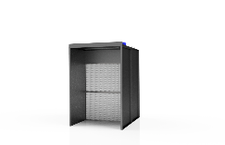 | 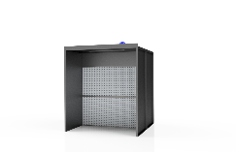 | 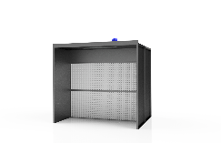 | 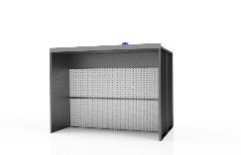 | 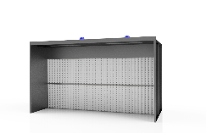 | 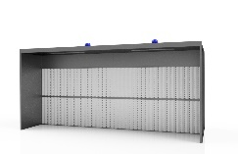 | 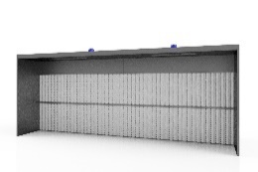
DRY FILTER BOOTHS – BC FANS – 2.25M | Model | SDFB-1.5 | SDFB-2 | SDFB-2.5 | SDFB-3 | SDFB-4 | SDFB-5 | SDFB-6
 | Front Opening | 1500w x 2250h | 2000w x 2250h | 2500w x 2250h | 3000w x 2250w | 4000w x 2250h | 5000w x 2250h | 6000w x 2250h
 | Width | 1600 | 2100 | 2600 | 3100 | 4100 | 5100 | 6100
 | Depth | 2000 | 2000 | 2000 | 2000 | 2000 | 2000 | 2000
 | Height | 2370 | 2370 | 2370 | 2370 | 2370 | 2370 | 2370
 | Canopy Depth | 1000 | 1000 | 1000 | 1000 | 1000 | 1000 | 1000
 | Airflow @0.7 M/Sec | 2.36 M³/Sec | 3.15 M³/Sec | 3.94 M³/Sec | 4.73 M³/Sec | 6.3 M³/Sec | 7.88 M³/Sec | 9.45 M³/Sec
 | Airflow @0.7 M/Sec | 8505 M³/Hr | 11340 M³/Hr | 14175 M³/Hr | 17010 M³/Hr | 22680 M³/Hr | 28350 M³/Hr | 34020 M³/Hr
 | Fan Qty | 1 | 1 | 1 | 1 | 2 | 2 | 2
 | Power kW | 1.1kW | 2.2 kW | 3 kW | 4 kW | 2.2 kW | 3 kW | 4 kW
 | Duct Diameter | 560 | 630 | 630 | 710 | 630 | 630 | 710
 | Lighting | 1 LED 40W | 1 LED 40W | 1 LED 40W | 1 LED 40W | 2 LED 40W | 2 LED 40W | 2 LED 40W

Axial Fan Dry Filter Booths provide a full height spray booth of 2250mm internally. These units are fitted with Axial Fans to provide adequate airflow. The duct connections are on the top for vertical exhaust. Depending on the size of booth, there are 1 or 2 exhaust fans and ducts required. The standard unit comes with a 1M long canopy fitted with LED lighting which can be extended if required.
An Axial Fan Dry Filter Booth typically extracts air from the painting area through two rows of dry filter media and exhausts to atmosphere. There are different types of filter media. We primarily offer the Andreae and Binks type concertina folded paper filters.
- Manufactured from Galvanised Steel
- Natural Finish or Optional Powder Coated Finish
- Modular Design
- Axial Fan Version
- For Wet Spray Processes

All standard units are provided with extraction for a maximum of 6M straight and 2x90° bends.

 |  | 1.5M Axial Fan | 2M Axial Fan | 2.5M Axial Fan | 3M Axial Fan | 4M Axial Fan | 5M Axial Fan | 6M Axial Fan
 |  | 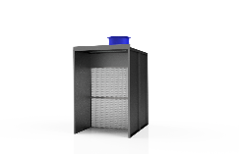 | 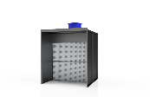 | 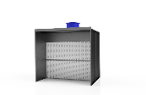 | 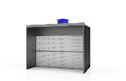 | 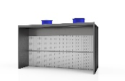 | 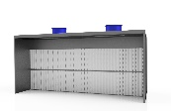 | 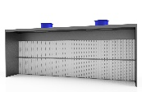
DRY FILTER BOOTHS – AXIAL FANS – 2.25M | Model | SDFA-1.5 | SDFA-2 | SDFA-2.5 | SDFA-3 | SDFA-4 | SDFA-5 | SDFA-6
 | Front Opening | 1500w x 2250h | 2000w x 2250h | 2500w x 2250h | 3000w x 2250w | 4000w x 2250h | 5000w x2250 | 6000w x 2250h
 | Width | 1600 | 2100 | 2600 | 3100 | 4100 | 5100 | 6100
 | Depth | 1000 | 1000 | 1000 | 1000 | 1000 | 1000 | 1000
 | Height | 2300 | 2300 | 2300 | 2300 | 2300 | 2300 | 2300
 | Canopy Depth | 1000 | 1000 | 1000 | 1000 | 1000 | 1000 | 1000
 | Airflow @0.7 M/Sec | 2.36 M³/Sec | 3.15 M³/Sec | 3.94 M³/Sec | 4.73 M³/Sec | 6.3 M³/Sec | 7.88 M³/Sec | 9.45 M³/Sec
 | Airflow @0.7 M/Sec | 8505 M³/Hr | 11340 M³/Hr | 14175 M³/Hr | 17010 M³/Hr | 22680 M³/Hr | 28350 M³/Hr | 34020 M³/Hr
 | Fan Qty | 1 | 1 | 1 | 1 | 2 | 2 | 2
 | Fan Diameter | 630 | 630 | 630 | 630 | 630 | 630 | 630
 | Power kW | 1.1kW | 1.5 kW | 2.2 kW | 2.2 kW | 1.5 kW | 2.2 kW | 2.2 kW
 | Duct Diameter | 560 | 630 | 630 | 710 | 630 | 630 | 710
 | Lighting | 1 LED 40W | 1 LED 40W | 1 LED 40W | 1 LED 40W | 2 LED 40W | 2 LED 40W | 2 LED 40W

Extended Height Dry Filter Booths provide an increased height spray booth of 3000mm internally. These units are fitted with Axial Fans to provide adequate airflow. The duct connections are on the top for vertical exhaust. Depending on the size of booth, there are 1 or 2 exhaust fans and ducts required. The standard unit comes with a 1M long canopy fitted with LED lighting which can be extended if required.
An extended dry filter booth typically extracts air from the painting area through three rows of dry filter media and exhausts to atmosphere. There are different types of filter media. We primarily offer the Andreae and Binks type concertina folded paper filters.

- Manufactured from Galvanised Steel
- Natural Finish or Optional Powder Coated Finish
- Modular Design
- Axial Fans
- For Wet Spray Processes

All standard units are provided with extraction for a maximum of 6M straight and 2x90° bends.

 |  | 2M Axial Fan | 2.5M Axial Fan | 3M Axial Fan | 4M Axial Fan | 5M Axial Fan | 6M Axil Fan
 |  | 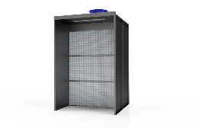 | 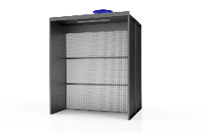 | 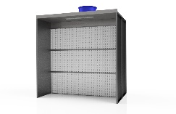 | 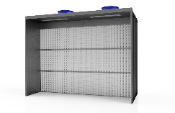 | 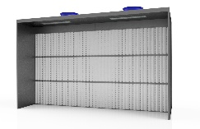 | 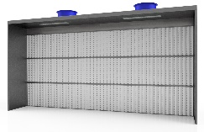
DRY FILTER BOOTHS – AXIAL FANS – 3M | Model | SDFAT-2 | SDFAT-2.5 | SDFAT-3 | SDFAT-4 | SDFAT-5 | SDFAT-6
 | Front Opening | 2000w x 3000h | 2500w x 3000h | 3000w x 3000w | 4000w x 3000h | 5000w x 3000h | 6000w x 3000h
 | Width | 2100 | 2600 | 3100 | 4100 | 5100 | 6100
 | Depth | 2000 | 2000 | 2000 | 2000 | 2000 | 2000
 | Height | 3120 | 3120 | 3120 | 3120 | 3120 | 3120
 | Canopy Depth | 1000 | 1000 | 1000 | 1000 | 1000 | 1000
 | Airflow @0.7 M/Sec | 4.2 M³/Sec | 5.25 M³/Sec | 6.3 M³/Sec | 8.4 M³/Sec | 10.5 M³/Sec | 12.6 M³/Sec
 | Airflow @0.7 M/Sec | 15120 M³/Hr | 18900 M³/Hr | 22680 M³/Hr | 30240 M³/Hr | 37800 M³/Hr | 45360 M³/Hr
 | Fan Qty | 1 | 1 | 1 | 2 | 2 | 2
 | Fan Diameter | 630 | 630 | 710 | 630 | 630 | 710
 | Power kW | 2.2 kW | 3 kW | 4 kW | 2.2 kW | 3 kW | 4 kW
 | Duct Diameter | 710 | 800 | 800 | 710 | 710 | 800
 | Lighting | 1 LED 40W | 1 LED 40W | 1 LED 40W | 2 LED 40W | 2 LED 40W | 2 LED 40W

