Our Powder Booth extracts air from the painting area through a series of cylindrical cartridge filters located behind perforated screens. This cleans the air and leaves the powder on the outside of the filters. The filters can be cleaned by a blast of air from inside the filter blowing the powder off for collection into the base of the booth.
- Manufactured from Powder Coated Steel Panels.
- Unit segmented into 2 Filters and 1 Fan per metre width.
- Filters are cleaned using Compressed Air.
- For Powder Coating processes.
Powder Booths can be built into closed booth systems to vastly reduce external contamination of your painted products. Often put into conveyorised systems where 2 booths are positioned opposite facing each other to coat both sides of the product.

For those using just one colour, the powder can be reclaimed and used again. The exhaust air from the booth is clean and can vent back into the room or be ducted out to atmosphere.

 |  | 2m Powder Booth | 2m Powder Booth W/canopy |  |  |  | 3m Powder Booth | 3m Powder Booth W/canopy
2 Metre Powder Booths |  | 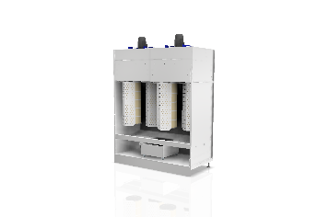 | 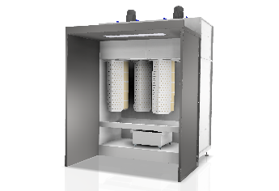 |  | 3 Metre Powder Booths |  | 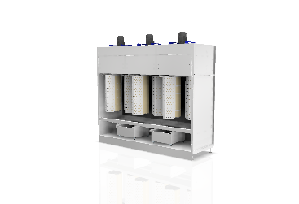 | 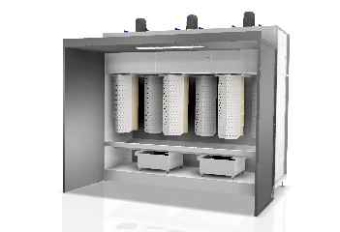
 |  | NO CANOPY | WITH CANOPY |  |  |  | NO CANOPY | WITH CANOPY
 | Width | 2080mm | 2080mm |  |  | Width | 3080mm | 3080mm
 | Depth | 941mm | 1940mm |  |  | Depth | 941mm | 1940mm
 | Height | 2600mm | 2600mm |  |  | Height | 2600mm | 2600mm
 | Filter Type | Reverse Jet Dust Filters | Reverse Jet Dust Filters |  |  | Filter Type | Reverse Jet Dust Filters | Reverse Jet Dust Filters
 | Extraction Fan Motor | 1.1Kw/415v/50hz/3Ph | 1.1Kw/415v/50hz/3Ph |  |  | Extraction Fan Motor | 1.1Kw/415v/50hz/3Ph | 1.1Kw/415v/50hz/3Ph
 | Fan Qty | 2 | 2 |  |  | Fan Qty | 3 | 3
 | Extraction Face Area | 1000mmx2250mm | 1000mmx2250mm |  |  | Extraction Face Area | 1000mmx2250mm | 1000mmx2250mm
 | Face Velocity | 0.7 m/sec | 0.7 m/sec |  |  | Face Velocity | 0.7 m/sec | 0.7 m/sec
 | Airflow | 5.5BarG (80PSI) | 5.5BarG (80PSI) |  |  | Airflow | 5.5BarG (80PSI) | 5.5BarG (80PSI)
 | Fan Type | Plug Fan – Direct Driven | Plug Fan – Direct Driven |  |  | Fan Type | Plug Fan – Direct Driven | Plug Fan – Direct Driven
 | Ductwork | Non-Required | Non-Required |  |  | Ductwork | Non-Required | Non-Required
 | Lighting | Optional LED Roof Mounted Light panels | Optional LED Roof Mounted Light panels |  |  | Lighting | Optional LED Roof Mounted Light panels | Optional LED Roof Mounted Light panels
 | Finishing Technology 2023. Airflow measured over open front face only. All dimensions in mm unless otherwise stated |  |  |  |  | Finishing Technology 2023. Airflow measured over filter media only as there is no canopy. All dimensions in mm unless otherwise stated

