Our Water Wash Booths provide a constant vertical wall of water for the airflow of the booth to impact against. The water washes away any airborne particles into a collection tank in the base. Chemicals are typically added to separate the paint from the water so it can be skimmed off at intervals.
The booth airflow is sucked under the water screen and up through the back of the booth through a scrubber system to remove any airborne contaminants and deposits them back into the water. As a secondary precaution the air is sucked through eliminator screens to remove any other contaminants that may still be in the airflow. The booth is exhausted to atmosphere. One pump recirculates the water to the scrubber system and water screen.
The base tank is Stainless Steel and provides multiple removable mesh screens to prevent any large build ups getting into the pump. The body of the booth is available in either Galvanised Steel or Stainless Steel.
- Manufactured from Galvanised Steel or Stainless Steel
- One pump system for scrubber and water screen
- Filter Screens to protect the pump
- For Wet Painting and Powder Coating processes

Water Wash Booths can be built into closed booth systems to vastly reduce external contamination of your painted products. Can be placed into conveyorised and robotic systems.

 |  | 1.5m Water Wash | 2m Water Wash | 2.5m Water Wash | 3m Water Wash | 4m Water Wash | 5m Water Wash | 6m Water Wash
 |  | 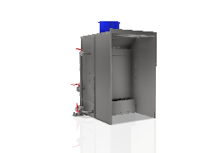 | 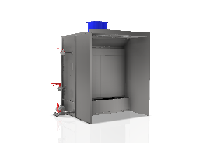 | 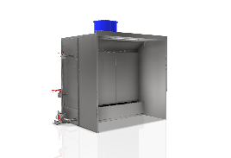 | 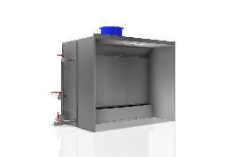 | 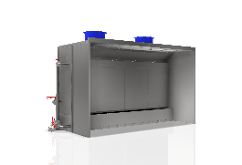 | 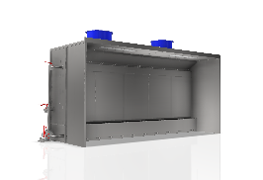 | 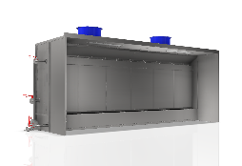
Water Washes | Width | 2006mm | 2506mm | 3006mm | 3506mm | 4506mm | 5506mm | 6506mm
 | Depth | 2003mm | 2003mm | 2003mm | 2003mm | 2000mm | 2003mm | 2003mm
 | Height | 2620mm | 2620mm | 2620mm | 2620mm | 2620mm | 2620mm | 2620mm
 | Depth to Screen | 1266mm | 1266mm | 1266mm | 1266mm | 1266mm | 1266mm | 1266mm
 | Canopy Depth | 1000mm | 1000mm | 1000mm | 1000mm | 1000mm | 1000mm | 1000mm
 | Pump Type | HC – 1.5KW | HC – 1.5KW | HC – 2.2KW | HC – 3.0KW | HC – 4.0KW | HC – 4.0KW | HC – 4.0KW
 | Airflow @0.7 M/Sec | 2.62M3/sec | 3.50M3/sec | 4.37M3/sec | 5.25M3/sec | 7.0M3/sec | 8.75M3/sec | 10.5M3/sec
 | Fan Type | 630 BDA | 630 BDA | 710 BDA | 710 BDA | 630 BDA | 710 BDA | 710 BDA
 | Fan Qty | 1 | 1 | 1 | 1 | 2 | 2 | 2
 | Power kW | 2.2KW | 3.0KW | 3.0KW | 4.0KW | 2.2KW x2 | 3.0KW x2 | 4.0KW x2
 | Duct Diameter | 630mm | 630mm | 710mm | 710mm | 630mm | 710mm | 710mm
 | Lighting | 1-LED 40W | 1-LED 40W | 1-LED 40W | 1-LED 40W | 2-LED 40W | 2-LED 40W | 2-LED 40W

 |  | 2m Water Wash Tall | 2.5m Water Wash Tall | 4m Water Wash Tall | 5m Water Wash Tall | 6m Water Wash Tall
 |  | 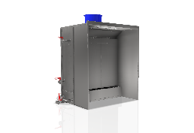 | 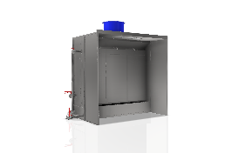 | 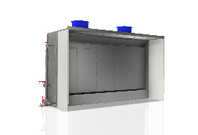
Water Washes Tall | Width | 2506mm | 3006mm | 4506mm | 5506mm | 6506mm
 | Depth | 2003mm | 2003mm | 2003mm | 2003mm | 2003mm
 | Height | 3120mm | 3120mm | 3120mm | 3120mm | 3120mm
 | Depth to Screen | 1266mm | 1266mm | 1266mm | 1266mm | 1266mm
 | Canopy Depth | 1000mm | 1000mm | 1000mm | 1000mm | 1000mm
 | Pump Type | HC – 2.2KW | HC – 3.0KW | HC – 4.0KW | HC – 4.0KW | HC – 5.5KW
 | Airflow @0.7 M/Sec | 4.20M3/sec | 4.37M3/sec | 8.40M3/sec | 10.5M3/sec | 12.6M3/sec
 | Fan Type | 710 BDA | 710 BDA | 710 BDA | 710 BDA | 710 BDA
 | Fan Qty | 1 | 1 | 2 | 2 | 2
 | Power kW | 3.0KW | 3.0KW | 3.0KW x2 | 3.0Kw x2 | 4.0KW x2
 | Duct Diameter | 710mm | 710mm | 710mm | 710mm | 710mm
 | Lighting | 1-LED 40W | 1-LED 40W | 2-LED 40W | 2-LED 40W | 2-LED 40W

